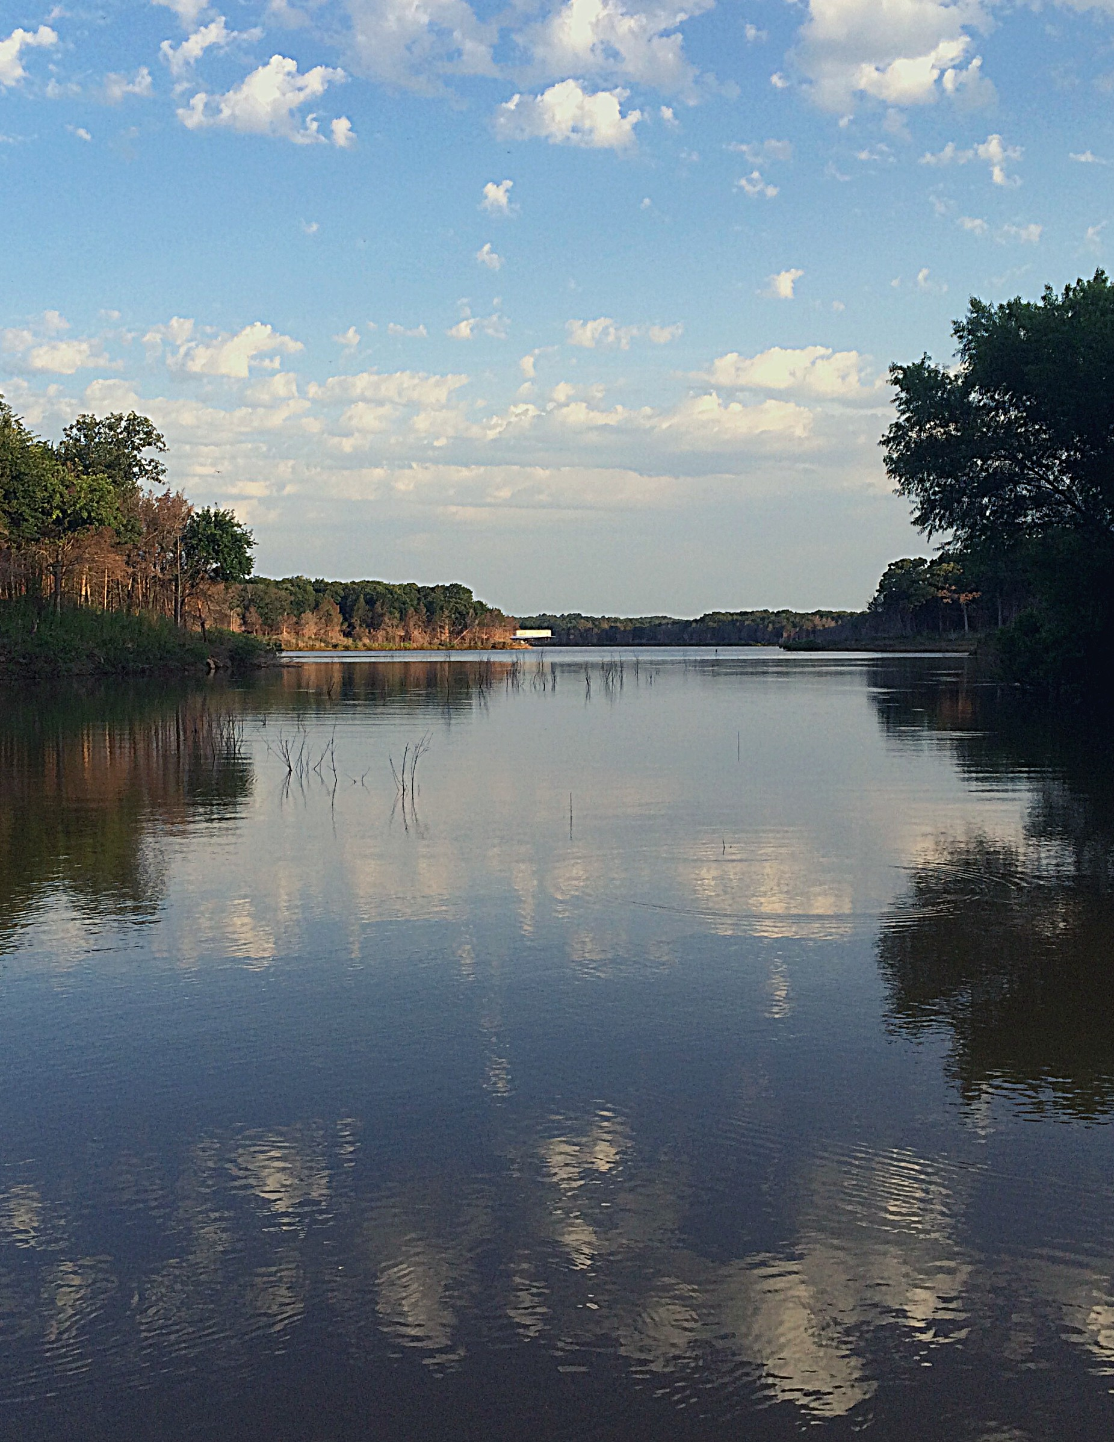

N O W O F F E R I N G ! ! !
RENTALS AVAILABLE FOR FAMILY CAMPING AT CAMP ALL SAINTS

- 2 NIGHT MINIMUM ON WEEKENDS
- BY RESERVATION ONLY

L A K E T E X O M A - W W W . C A M P A L L S A I N T S . C O M - 9 0 3 - 7 8 6 - 3 1 48

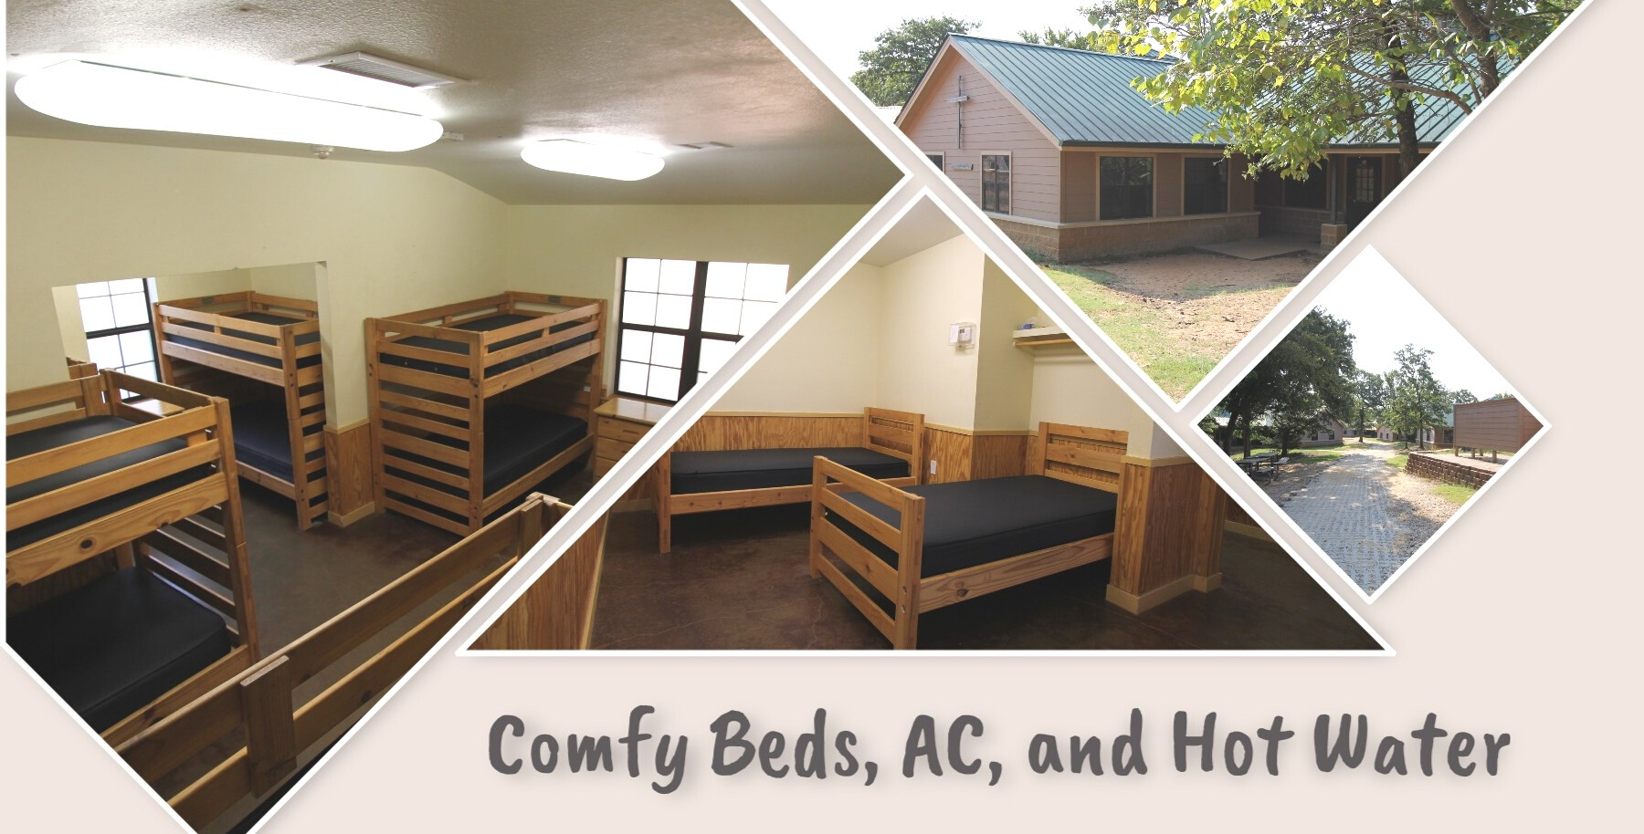

L A K E T E X O M A - W W W . C A M P A L L S A I N T S . C O M - 9 0 3 - 7 8 6 - 3 1 48

CABINS

$ 1 7 5 P E R N I G H T U P T O 6 P E O P L E
- $ 2 5 E X T R A P E R P E R S O N

Each Cabin includes the following:

- 12 beds in a bunk style room with shared bathroom (3 stalls and 3 showers)

- 2 beds in a semi private room with a private bathroom and shower

- AC and Hot Water

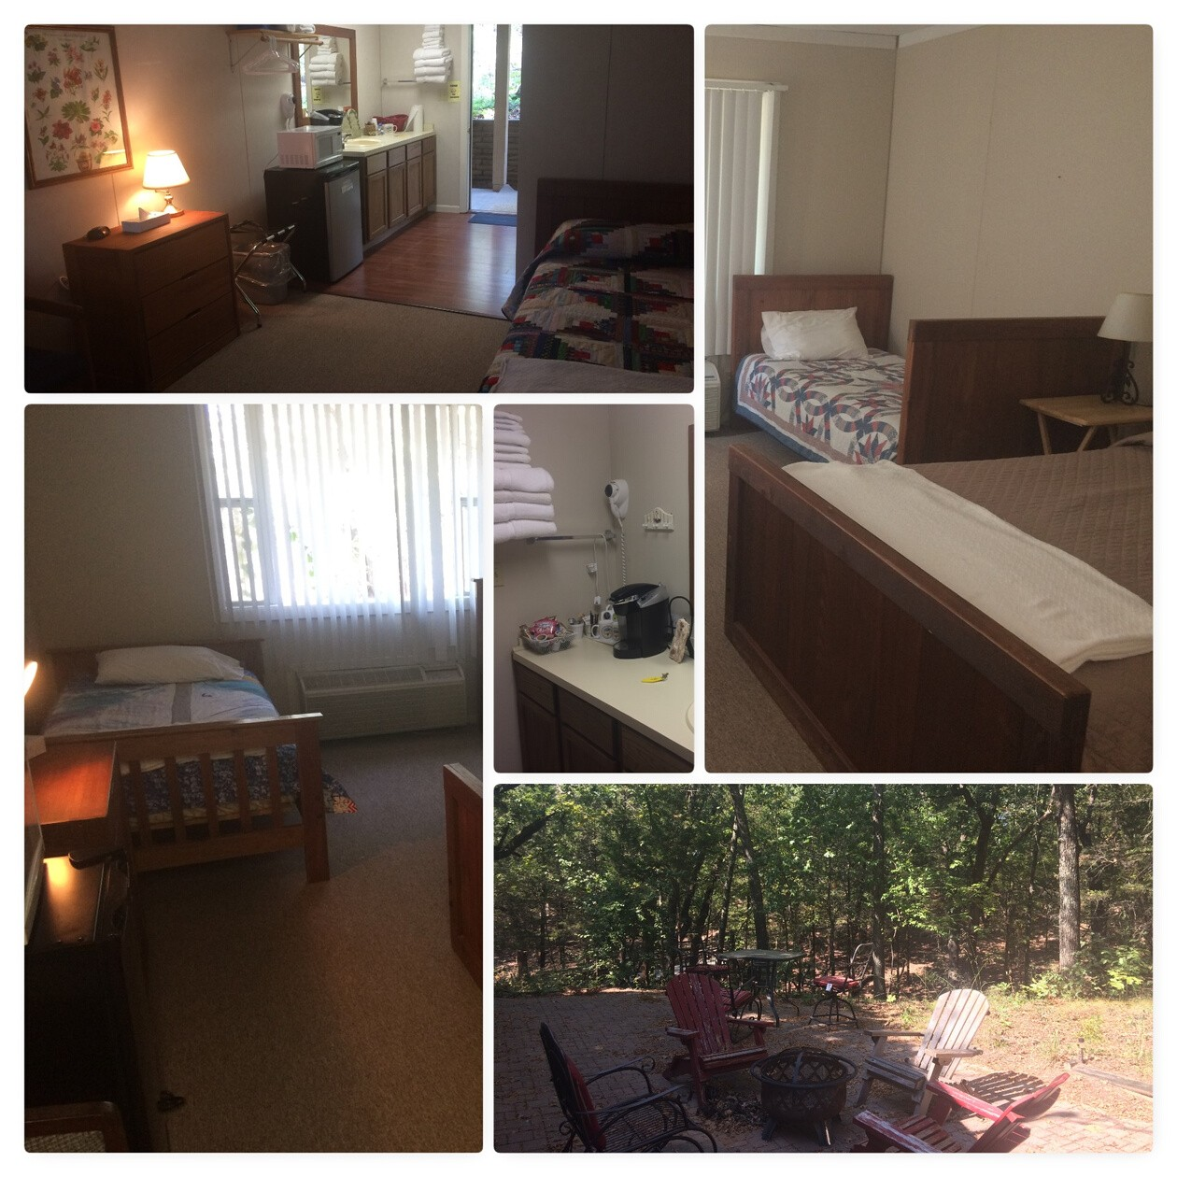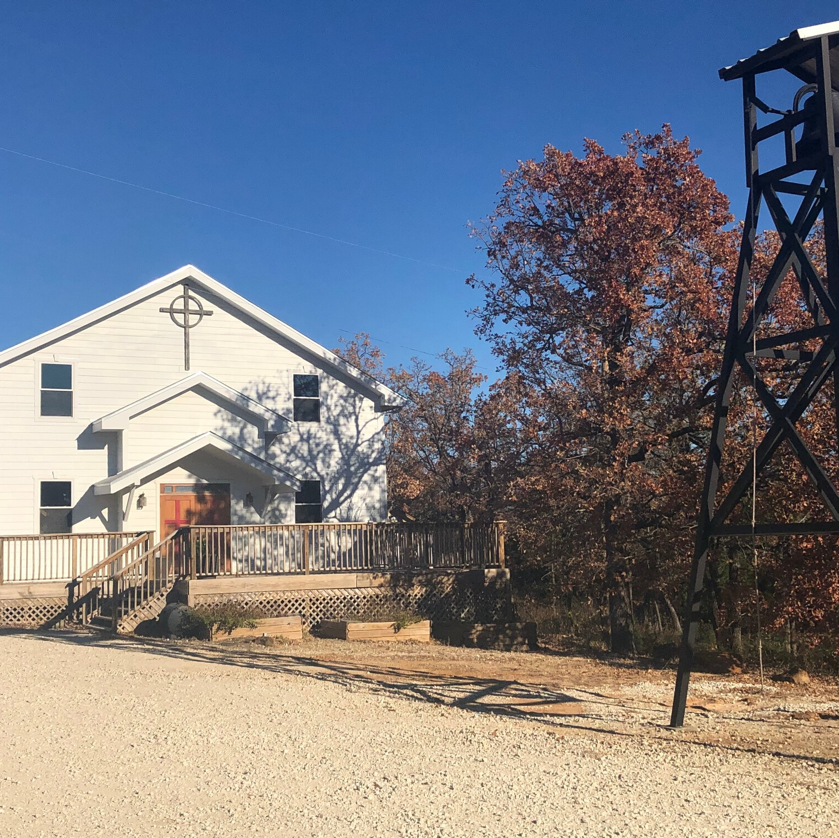

L A K E T E X O M A - W W W . C A M P A L L S A I N T S . C O M - 9 0 3 - 7 8 6 - 3 1 48

MOTELS

$ 1 0 0 P E R N I G H T

Each Motel includes the following:

- Sleeps 3-4 people

- 1 full bed/2 twins

- Private Bathroom w/ Shower

- AC and Hot Water

- Microwave/ Mini Fridge/ Coffee Maker
L A K E T E X O M A - W W W . C A M P A L L S A I N T S . C O M - 9 0 3 - 7 8 6 - 3 1 48

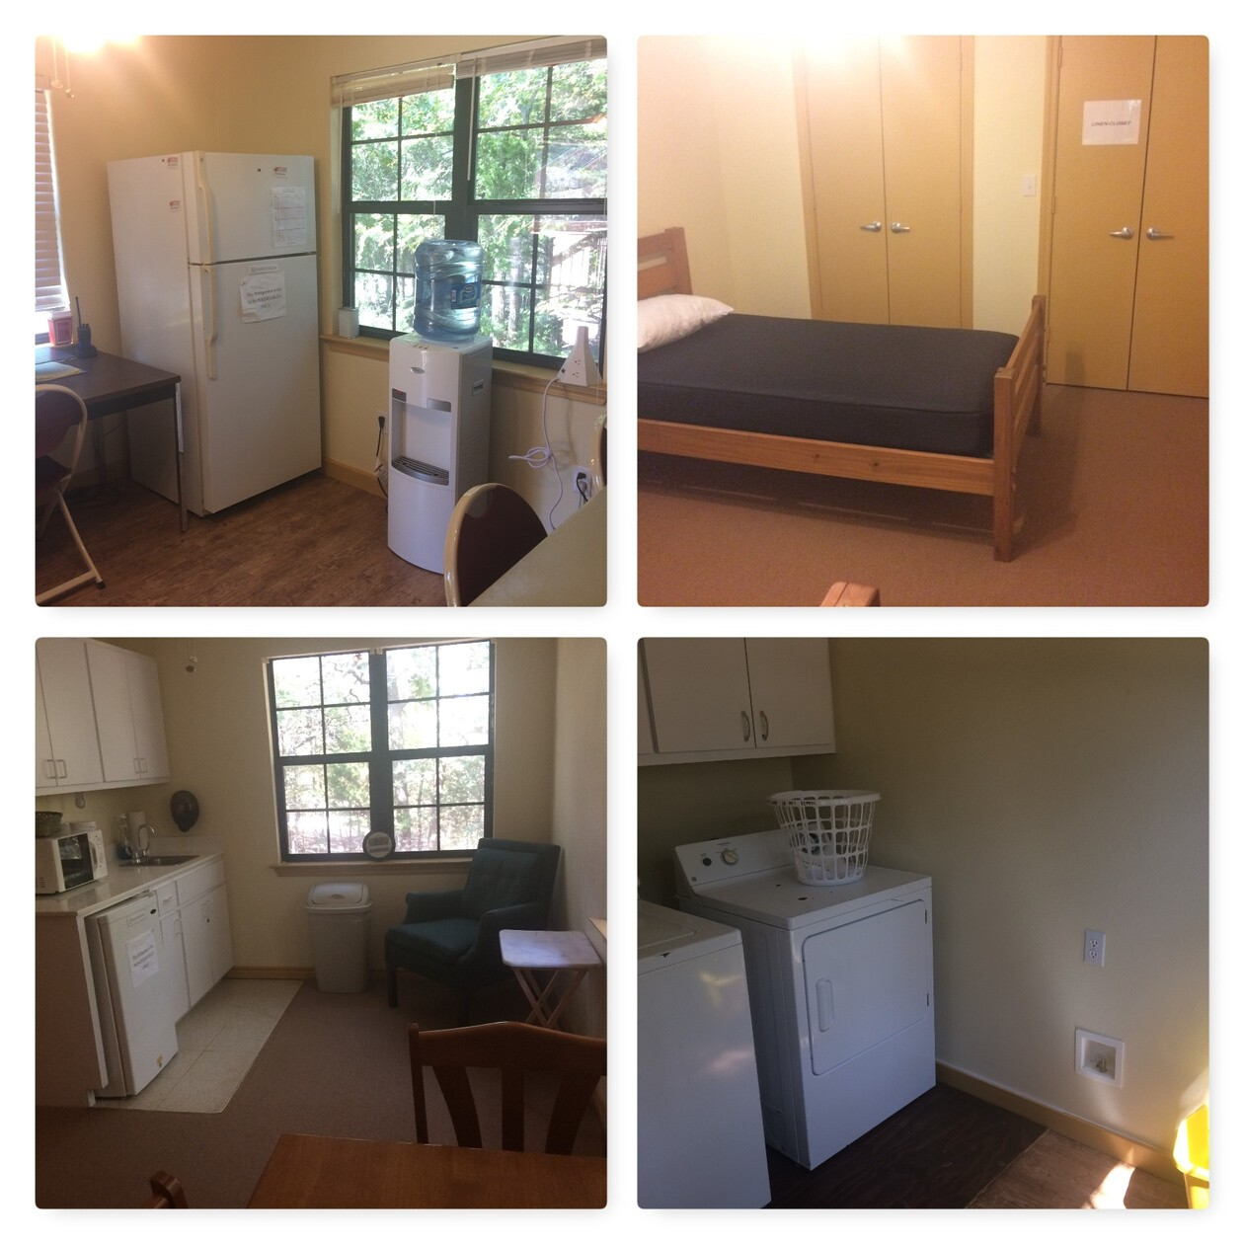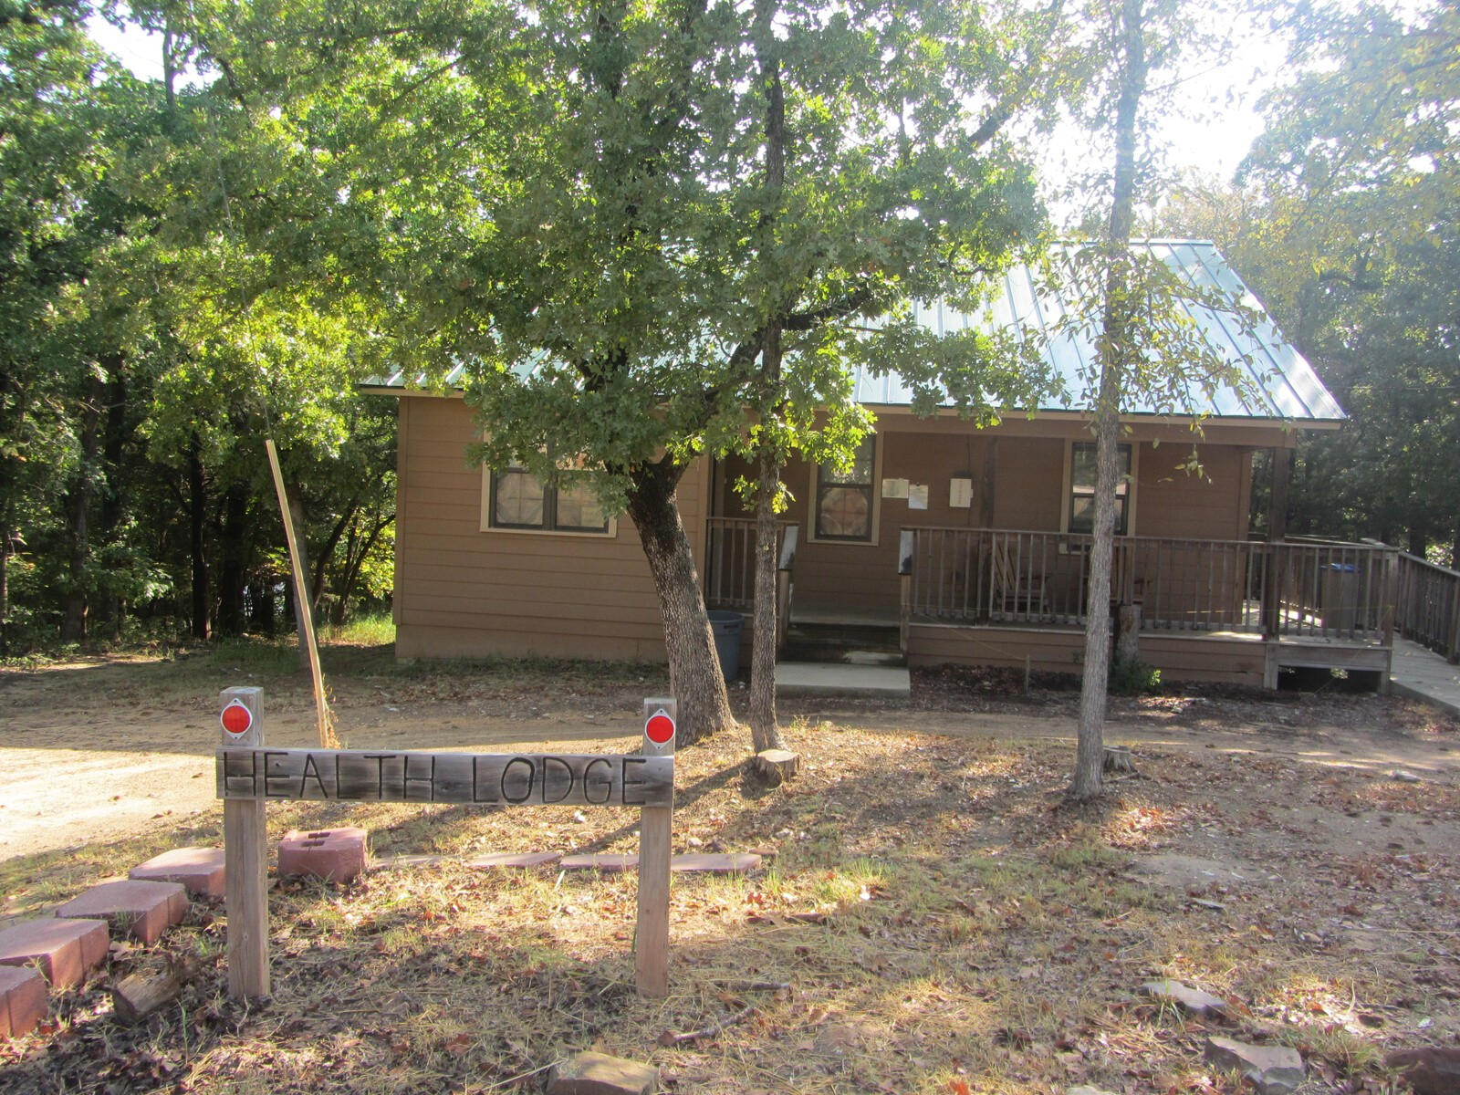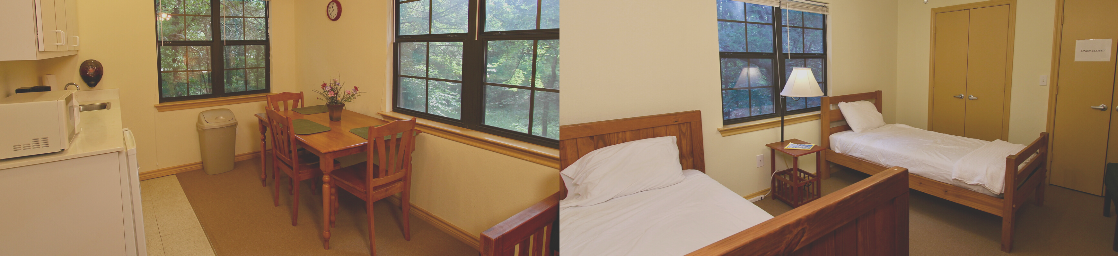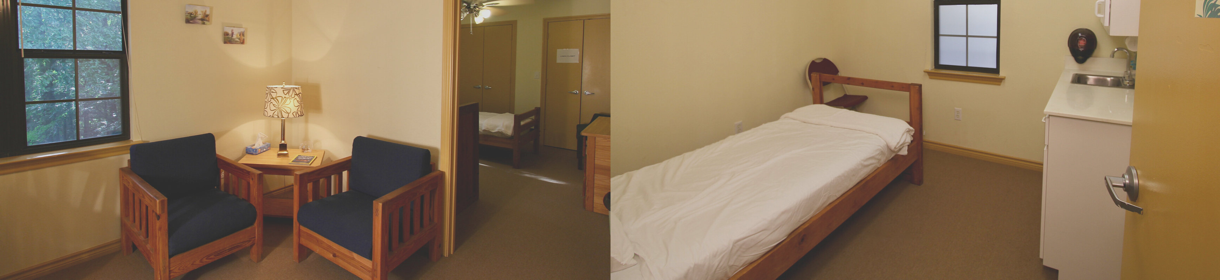

L A K E T E X O M A - W W W . C A M P A L L S A I N T S . C O M - 9 0 3 - 7 8 6 - 3 1 48

THE LODGE

$ 2 0 0 P E R N I G H T

The lodge includes the following:

- sleeps up to 4

- 3 beds/2 bath living arrangement

- small living room/ kitchenette

- private porch patio

- AC and Hot Water

- wifi on site
L AKE T E XOMA - WWW. C AMP AL L S AINT S . C OM - 903 - 786 - 31 48

